**T. Y. B. Tech (Electrical and Computer Engineering)**

**Trimester: V Subject: Microcontroller and Applications**

**Name: Shreerang Mhatre Class: TY**

**Roll No: 52 Batch: A3**

**Experiment No: 08**

**Name of the Experiment:** Implement UART with C8051F340

**Marks**

**Teacher’s Signature with date**

**Performed on: 5/12/2023**

**Submitted on: 7/12/2023**



**Aim:** Write a C program for serial communication using C8051F340 to transfer data from C8051F340 to PC

**Apparatus:** EPBF340 Board, Connectors

**Theory:** Serial Communication is of two types Synchronous and Asynchronous. The asynchronous mode is used to connect the C8051F340 to PC serial port for the purpose of full duplex serial data transfer.C8051F340 has inbuilt UART (Universal Asynchronous Receiver Transmitter). Baud rate is a significant factor for serial communication of microcontroller with other devices. For communication with PC the baud rate of 9600 is selected.

baud rate generation:

Timer-1 is used to generate baud rate for mode-1 serial communication by using overflow flag of the timer to determine the baud frequency. Timer-1 is used in timer mode-2 as an auto-reload 8-bit timer. The data rate is generated by timer-1 using the following formula.

TH1 = 256-(SYSCLK/Desired baud rate/2)

**Interfacing Diagram:**

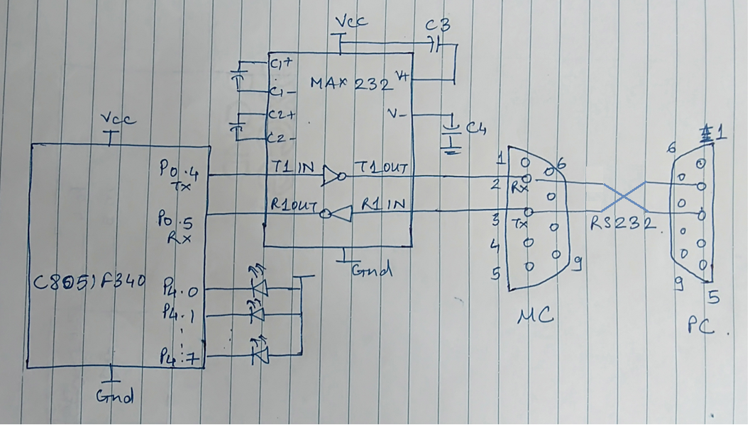

*Figure 4.1 Interfacing Diagram for UART*

**Program:**

**Expected Result:**

The string should be displayed on HyperTerminal.

**Conclusion:**

**--------------------------------------------------------------------------------------------------------------------------------------------------------------------------------------------------------------------------------**

**Study Question:**

1. Explain the need of MAX232 in serial communication.
2. Write the Port Properties for setting Hyper Terminal connection.
3. Explain UART registers.

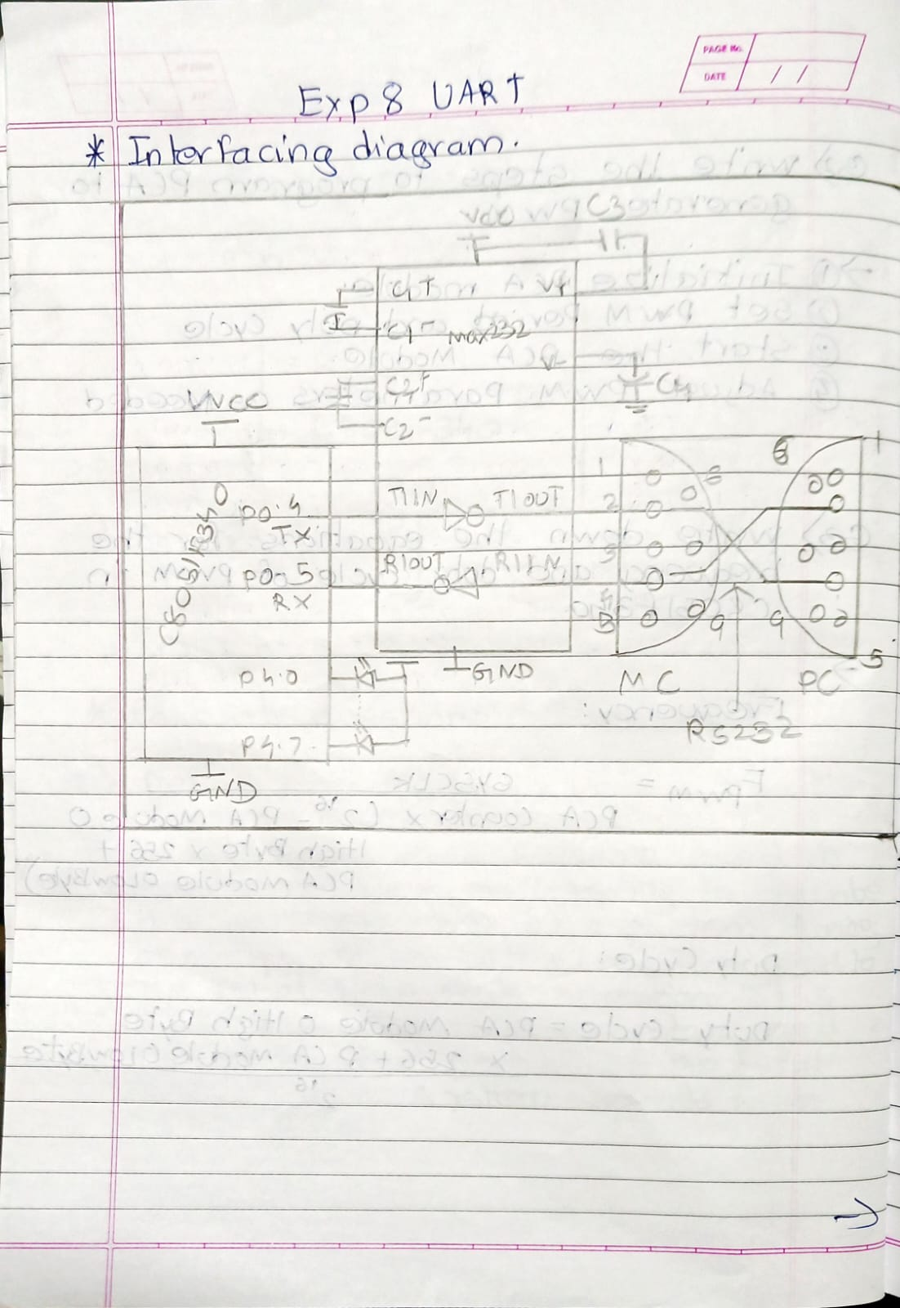

**Tranmission program for Uart with C8051F340**

// Exp - 8 Implement UART with C8051F340

/*

Name: Shreerang Mhatre

Rollno: 52

Batch: A3

Class: TY

Tranmission program:

*/

#include"c8051f340.h"

#define sysclk 12000000

#define BR_UART0 9600

void main()

{

    char ch[]=("SHREERANG");

    int i;

    OSCICN = 0X80;

    XBR0=0X01;

    XBR1=0X40;

    P0MDOUT=0X10;

    SCON0=0X00;

    CKCON=0X01;

    TH1=256-(sysclk/BR_UART0/2/4);

    TH1=TL1;

    TMOD=0x20;

    TR1=1;

    while(1)

    {

        for(i=0;ch[i]!='\0';i++)

        {

            SBUF0=ch[i];

            while(TI0==0);

        }

    }

}

**Reciving program for Uart with C8051F340**

// Exp - 8 Implement UART with C8051F340

/*

Name: Shreerang Mhatre

Rollno: 52

Batch: A3

Class: TY

Reciving Program:

*/

#include"c8051f340.h"

#define sysclk 12000000

#define BR_UART0 9600

sbit BUZZER=P3^3;

void main()

{

    OSCICN = 0X83;

    XBR0=0X01;

    XBR1=0X40;

    P3MDOUT=0X08;

    BUZZER=1;

    P0MDIN=0X20;

    P4MDOUT=0xFF;

    SCON0=0X10;

    CKCON=0X01;

    TH1=256-(sysclk/BR_UART0/2/4);

    TH1=TL1;

    TMOD=0x20;

    TR1=1;

    while(RI0==0)

    {

        P4=~SBUF0;

        RI0=0;

    }

}

**Transmission Output:**

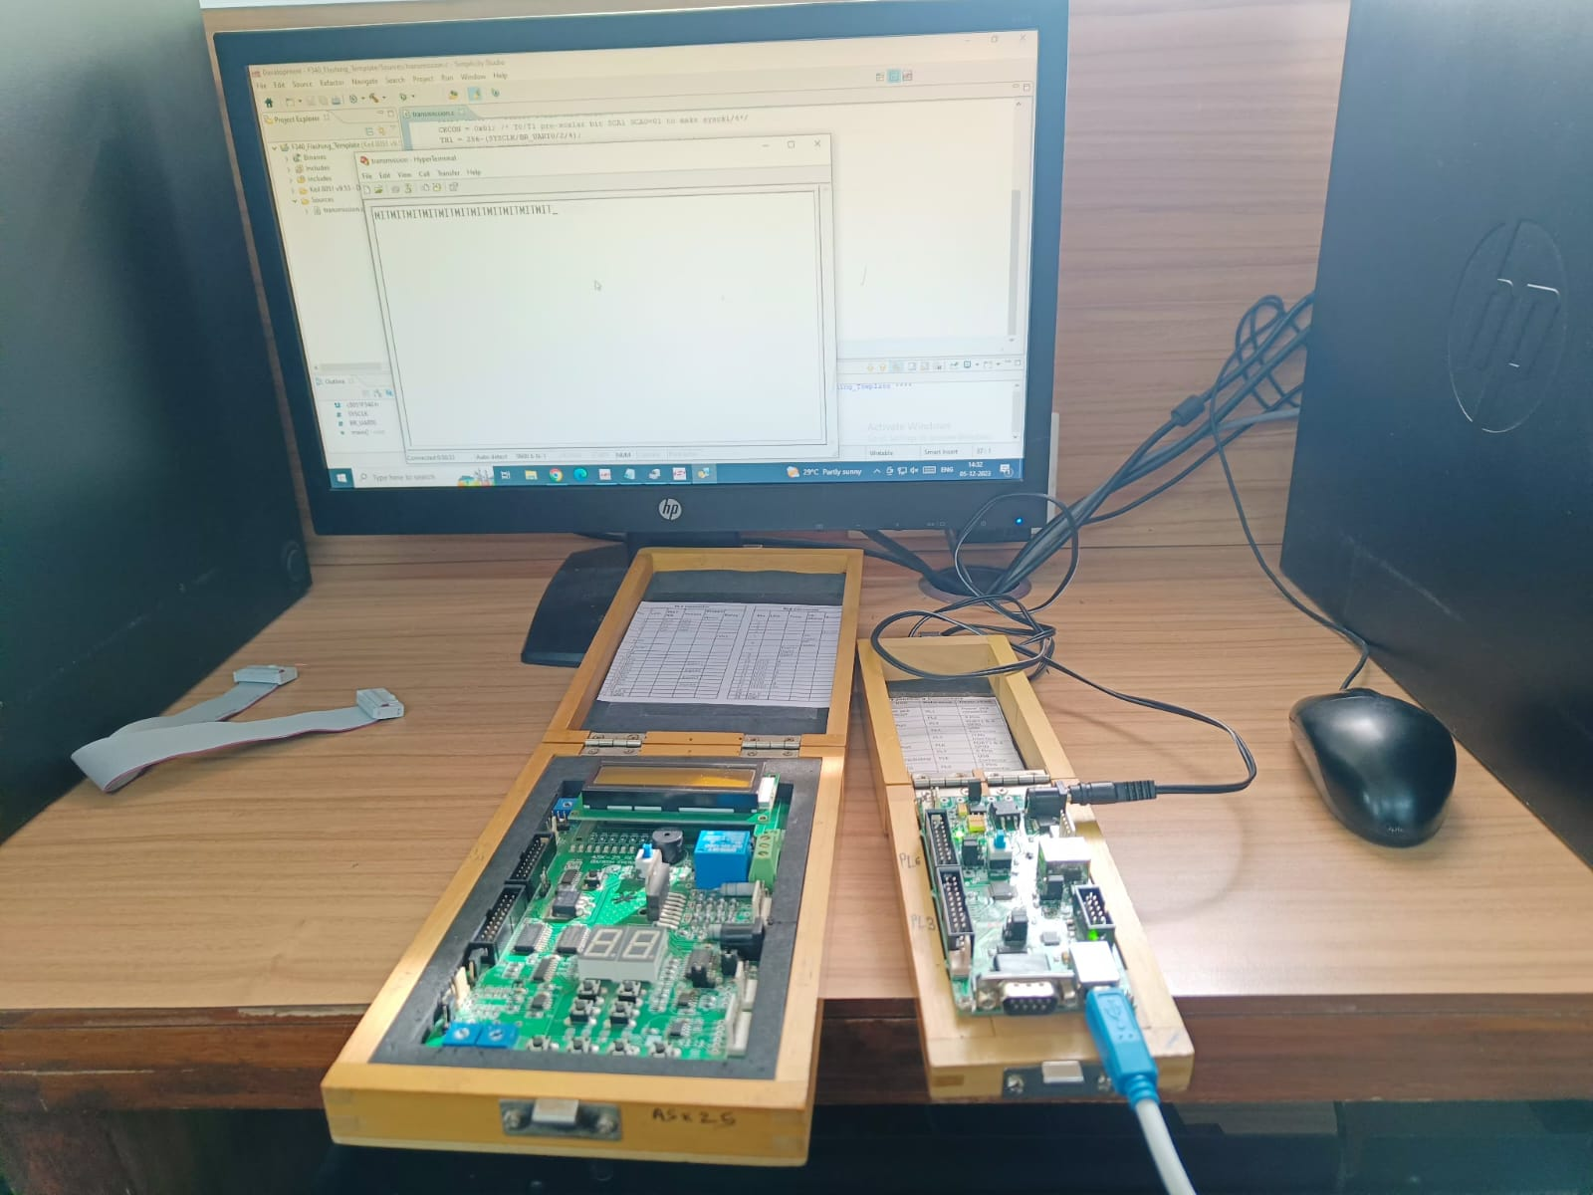

**Receiving Output:**

